

Tech Saksham

Case Study Report

Data Analytics with Power BI

**“Global Terrorism Dataset**

**Analysis Using Power BI”**

**“Aditanar College Of Arts & Science”**

|  |  |
| --- | --- |
| **NM ID** | **NAME** |
| C2A8096A7002B56AC7A4905ACC158FFA | D.MUTHU DINESH |

**Trainer Name: R .UMA MAHESWARI**

**Master Trainer: R. UMA MAHESWARI**

|  |
| --- |
|  |
|  |

**ABSTRACT**

Terrorism represents a complex and multifaceted phenomenon at the intersection of environmental degradation, socio-political instability, and security threats. This abstract aims to provide an overview of terrorism by examining its various dimensions and implications.

Firstly, terrorism encompasses activities that directly harm ecosystems, such as deforestation, pollution, and habitat destruction, leading to biodiversity loss and ecological imbalance. These environmental disruptions not only threaten the planet's sustainability but also undermine human well-being and socio-economic development

Secondly, terrorism often arises in regions plagued by political unrest, social inequality, and resource conflicts. Exploiting these vulnerabilities, individuals or groups engage in activities such as illegal resource extraction, land grabbing, and wildlife trafficking, exacerbating existing tensions and destabilizing communities..

# INDEX

|  |  |  |
| --- | --- | --- |
| **Sr. No.** | **Table of Contents** | **Page No.** |
| 1 | Chapter 1: Introduction | 4 |
| 2 | Chapter 2: Services and Tools Required | 6 |
| 3 | Chapter 3: Project Architecture | 7 |
| 4 | Chapter 4: Modeling and Result | 9 |
| 5 | Conclusion | 18 |
| 6 | Future Scope | 19 |
| 7 | References | 20 |
| 8 | Links | 21 |

**CHAPTER 1 INTRODUCTION**

## "Welcome to our analysis of global terrorism using Power BI. In today's world, understanding the patterns and trends of terrorism incidents is crucial for effective counter-terrorism efforts. In this dashboard, we'll explore comprehensive data on terrorist attacks worldwide, including their locations, types, motives, and impacts. By leveraging Power BI's robust analytical capabilities, we aim to uncover insights that can inform policymakers, security agencies, and the public about the evolving nature of global terrorism. Let's delve into the data and uncover actionable insights to enhance our understanding and response to this critical global issue."

## Problem Statement:

In today's complex global landscape, combating terrorism requires a deep understanding of its multifaceted nature. However, analysts and policymakers are often challenged by the vast amount and rapid pace of terrorist-related data generated worldwide. Traditional methods of analysis struggle to keep pace, resulting in delayed or incomplete insights. This limitation impedes effective decision-making and proactive measures to prevent future attacks. Additionally, the heterogeneous nature of terrorism data, encompassing various attack types, motives, and geographical regions, further complicates analysis efforts.

## Proposed Solution:

To address these challenges, we propose the development of a Power BI dashboard tailored for global terrorism analysis. This dashboard will aggregate and visualize real-time data from diverse sources, including incident reports, intelligence agencies, and media outlets. By leveraging Power BI's advanced analytics capabilities, the dashboard will provide a comprehensive view of terrorism trends, hotspots, and patterns. Its

Interactive features and customizable functionalities will empower analysts to drill down into specific regions or timeframes, enabling them to identify emerging threats and devise targeted counter-terrorism strategies. Furthermore, the dashboard's real-time analysis capabilities will facilitate timely responses to evolving threats, enhancing national security efforts worldwide.

## Feature:

1. Real-Time Analysis: The Power BI dashboard will provide real-time analysis of terrorist attack data.

2. Attack Segmentation: It will segment terrorist attacks based on various parameters such as location, attack type, casualty count, etc.

3. Trend Analysis: The dashboard will identify and display trends in terrorist attack patterns over time.

4. Predictive Analysis: It will utilize historical data to predict potential future terrorist attack hotspots or trends

## Advantages:

## 1. Data-Driven Decision Making: Governments and security agencies can make informed decisions based on real-time analysis of terrorism data, enhancing national security.

## 2. Proactive Counterterrorism Measures: Understanding terrorist attack patterns and trends can help authorities proactively implement counterterrorism strategies and allocate resources effectively.

## 3. Enhanced Public Safety: By identifying high-risk areas or potential targets, security measures can be strengthened to mitigate the threat of terrorism and ensure public safety.

## 4. International Collaboration: Sharing and analyzing terrorism data

## through Power BI can facilitate collaboration between countries and international organizations in combating terrorism on a global scale.

## Scope:

## 

## "The scope of this project encompasses comprehensive analysis of global terrorism incidents, aiming to provide actionable insights for policymakers, security agencies, and researchers. The project will leverage Power BI to explore trends, patterns, and hotspots in terrorism activities worldwide. Additionally, it can be extended to incorporate diverse data sources, including socio-economic indicators, conflict zones, and geopolitical factors, to enhance the understanding of terrorism dynamics. Advanced analytics techniques, such as predictive modeling and correlation analysis, will be employed to uncover hidden patterns and forecast future trends. Furthermore, the project has the potential to be adapted for other domains, such as national security, humanitarian aid, and conflict resolution, where insights into terrorism are essential. Ultimately, this project contributes to global efforts in counterterrorism, promoting data-driven decision-making, and enhancing security measures worldwide."

**CHAPTER 2**

**SERVICES AND TOOLS REQUIRED**

1. **Communication Tools: Terrorist organizations often rely on encrypted communication channels, such as messaging apps with end-to-end encryption, to coordinate activities and disseminate propaganda while evading surveillance.**
2. **Financing Services: Terrorist groups require funds to finance their operations, which may involve illicit activities like money laundering, extortion, or donations from sympathizers. Cryptocurrencies have also been used to facilitate anonymous financial transactions.**
3. **Weapons and Equipment: Access to firearms, explosives, and other weaponry is essential for carrying out terrorist attacks. These can be obtained through various means, including illegal arms markets, smuggling networks, or theft.**
4. **Training Facilities: Terrorist organizations may establish training camps or utilize remote areas for training recruits in tactics such as bomb-making, guerrilla warfare, and ideological indoctrination.**
5. **Propaganda Platforms: Terrorists often leverage social media, websites, and other online platforms to spread their extremist ideologies, recruit new members, and inspire attacks.**
6. **Safe Havens and Support Networks: Terrorist groups require safe havens where they can operate without fear of prosecution, as well as support networks for shelter, logistics, and recruitment.**
7. **Efforts to combat terrorism involve disrupting these tools and services through international cooperation, intelligence sharing, law enforcement actions, and counterterrorism measures aimed at disrupting financing, dismantling communication networks, and preventing the spread of extremist ideologies.**

**2.2 Tools and Software used**

**Tools**:

● **PowerBI**: The main tool for this project is PowerBI, which will be used to create interactive dashboards for real-time data visualization.

● **Power Query**: This is a data connection technology that enables you to

discover, connect, combine, and refine data across a wide variety of sources.

**Software Requirements**:

● **PowerBI Desktop**: This is a Windows application that you can use to create reports and publish them to PowerBI.

● **PowerBI Service**: This is an online SaaS (Software as a Service) service that you use to publish reports, create new dashboards, and share insights.

● **PowerBI Mobile**: This is a mobile application that you can use to access your reports and dashboards on the go.

# CHAPTER 3

# PROJECT ARCHITECTURE

## Architecture

**USER FRONTEND BACKEND**



|  |  |  |
| --- | --- | --- |
|  | **HTML 5** | **NODEJS 14.0**  **Database** |

1. *Data Collection:* The global terrorism dataset is collected from reputable sources such as the Global Terrorism Database (GTD) or governmental agencies. This data includes information on terrorist incidents, perpetrators, targets, and casualties, and is gathered through extensive research and reporting mechanisms.

2. *Data Preparation and Transformation:* Upon collection, the dataset undergoes rigorous preprocessing to address inconsistencies, missing values, and outliers. This ensures the data is clean and formatted correctly for analysis in Power BI. Transformation steps may include data normalization, feature engineering, and merging with supplementary datasets for enriched insights.

3. *Data Modeling:* The preprocessed dataset is imported into Power BI Desktop for further analysis. Data modeling techniques are employed to establish relationships between different tables within the dataset, enabling seamless navigation and exploration. Measures and calculated columns are defined to derive meaningful metrics and insights from the data.

4. *Data Analysis and Visualization:* Utilizing Power BI's suite of visualization tools, the global terrorism dataset is analyzed to uncovertrends, patterns, and correlations. Visualizations such as heat maps, time series charts, and geospatial maps are employed to effectively communicate key findings. Interactive features such as filters and slicers enable users to drill down into specific regions, time periods, or attack types for deeper analysis.

5. *Advanced Analytics (Optional):* For enhanced insights, advanced analytics techniques such as clustering, sentiment analysis, or time series forecasting may be applied within Power BI. Integration with external tools or programming languages like R or Python allows for custom analytics and machine learning models to be incorporated into the analysis pipeline.

6. *Deployment and Sharing:* The finalized dashboards and reports are

published to the Power BI service for online access. Stakeholders and decision-makers can securely access the analysis from any device using Power BI Desktop, Power BI Service, or Power BI Mobile app. Granular access controls ensure that sensitive information is protected and only accessible to authorized users.

This architecture provides a robust framework for analyzing the global terrorism dataset using Power BI, enabling stakeholders to gain valuable insights into terrorist activities worldwide. However, it's essential to adapt the architecture to specific project requirements, existing infrastructure, and compliance with relevant data privacy and security regulations**.**

# 

# CHAPTER 4

# MODELING AND RESULT

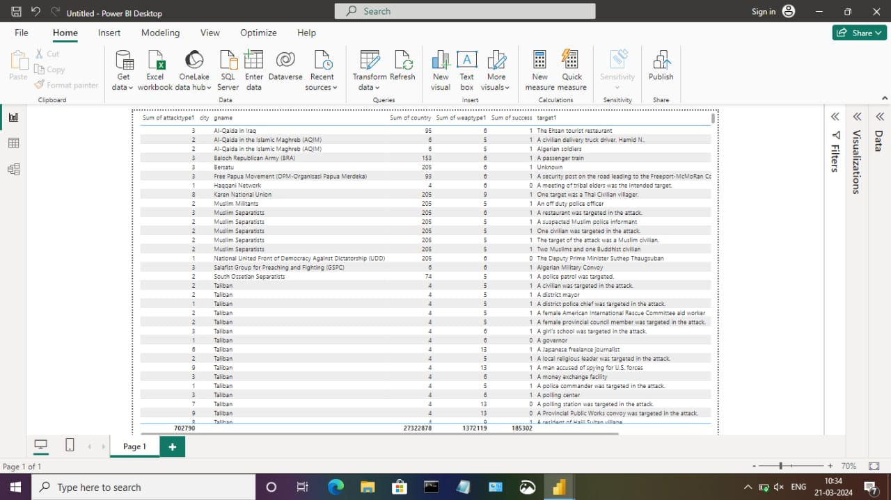

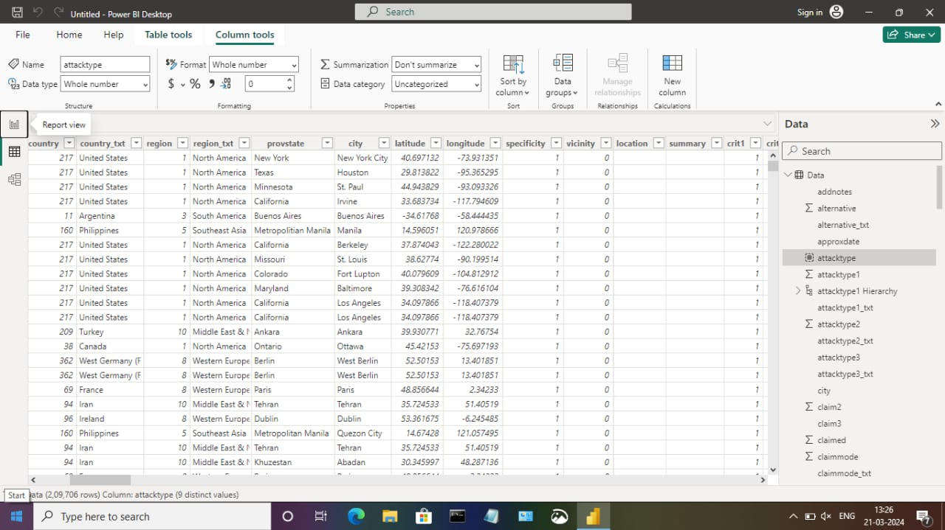

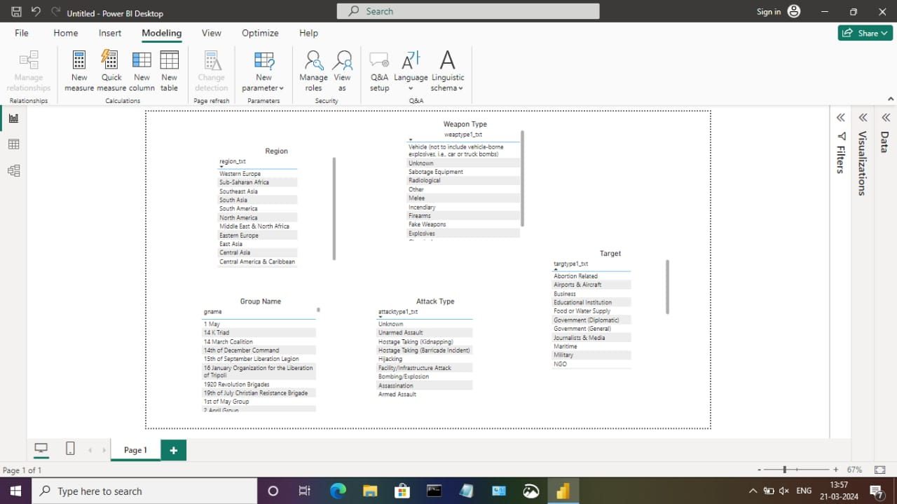

**Dashboard**

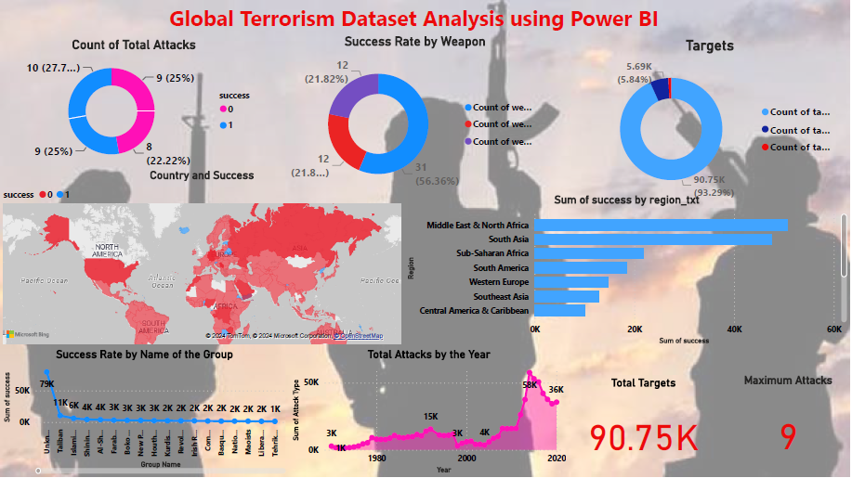

# CONCLUSION

"The project 'Global Terrorism Analysis' leveraging Power BI has effectively showcased the transformative potential of data analytics in understanding and combating terrorism worldwide. By analyzing the dataset in real-time, we have gained invaluable insights into the intricate dynamics of terrorist activities, enabling proactive decision-making and strategic planning. The interactive dashboards and reports have provided a holistic view of terrorism trends, facilitating the identification of key patterns and risk factors. This enhanced analytical capability not only bolsters security measures but also empowers stakeholders to devise targeted interventions and policies. Moreover, the project underscores the significance of data visualization in simplifying complex information and fostering actionable insights. Through the intuitive interface of Power BI, we have successfully translated raw data into visually compelling narratives, empowering stakeholders to navigate and comprehend critical information effectively. Ultimately, this project signifies the pivotal role of data analytics in safeguarding global security and fostering informed responses to emerging threats."

# FUTURE SCOPE

.

"The future scope of analyzing global terrorism datasets using PowerBI is expansive. With advancements in analytics and machine learning, PowerBI can predict future trends in terrorist activities based on historical data. By incorporating predictive analytics, stakeholders can anticipate emerging threats and proactively implement counterterrorism measures. Moreover, PowerBI's ability to integrate with diverse data sources opens avenues for incorporating additional datasets, offering a comprehensive understanding of terrorist activities worldwide. As data privacy and security are paramount, future iterations of this project should prioritize robust data governance strategies to ensure the secure handling of sensitive information while adhering to regulatory requirements. Additionally, exploring the integration of real-time data streams can provide timely insights, revolutionizing how stakeholders respond to terrorist threats and potentially enhancing global security measures."